Setup github for dummies

**Install the github**  
<https://git-scm.com/downloads>

Remember to check the boxes for windows integration (the Git bash box)

**Open the Git bash terminal:** (Should look like this)

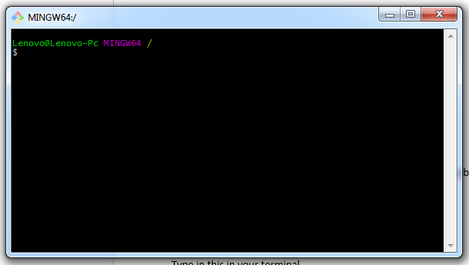

**Type in this in your terminal:**

git config --global user.name "John Doe"

git config --global user.email johndoe@example.com

This needs to be your github email

**Setup you system with a SSH-key so you don’t need to type in password all the time.**

First we need to generate the key for you system

<https://help.github.com/articles/generating-a-new-ssh-key-and-adding-it-to-the-ssh-agent/>

This guide is step by step, so you shouldn’t be able to fuck it up

***Remember when you are prompted for a passphrase in the guide. Just hit enter! With no passphrase, you won’t need to type it every time you commit***

**Now you need to add the key from your system to your Github account**

<https://help.github.com/articles/adding-a-new-ssh-key-to-your-github-account/>

Again, this shouldn’t be fuckable

When this is done, your computer should have automatically gained access to github without you needing to type credentials every time

**You did it! Now lets get the repository downloaded/setup.**

Go to the github repository on <http://www.Github.com> that you wan’t to work on, and find the following webpage:

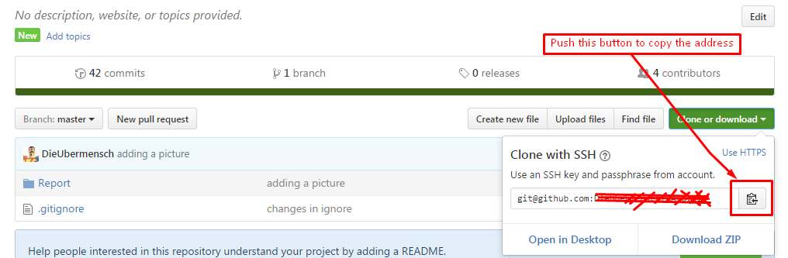

Copy the address by pushing the button.

**Now we navigate to the folder you want the repository to be stored:**

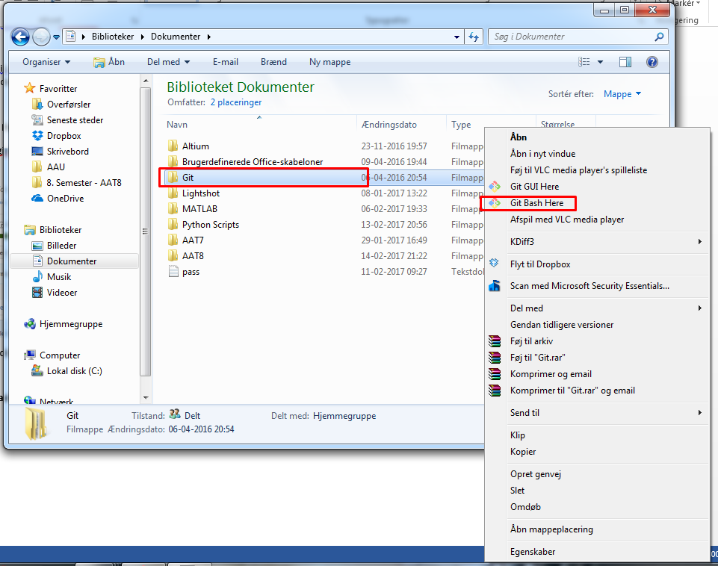

Right click the folder and do a ‘’git bash here’’.

Its waaaaaay easier to navigate to the desired this way, instead of a ls -> ls -> ls -> ls -> ls -> ls -> ls -> ls -> ls -> ls -> ls -> ls -> ls -> ls -> ls -> ls -> ls -> ls -> ls -> ls -> ls -> ls -> ls -> ls -> ls -> ls -> ls -> ls -> ls (let the linux guys worry about that).

Now you terminal should look like this, or whatever path you got on your computer:

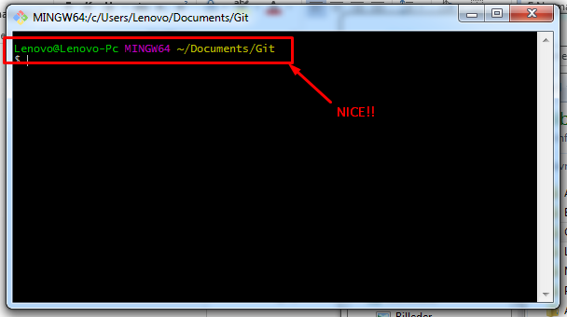

**Now comes this easy part, we want to clone the repository:**

**Hit**

git clone (The link you copied from the webpage goes here)

This is easy copy pasted in, by using the ‘’Insert’’ Button on your computer.

The repository should now be downloaded:

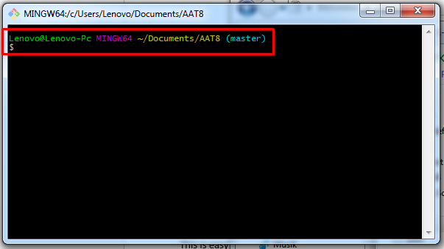

You can see that you are in the repository by the (master) in the terminal.

Now you are ready to commit, push and pull all the stuff you need.

**CHEATSHEET:**

**Adding a new file or picture:**

git add .

**Adding stuff/changes to already commited files on the repo:**

git commit –am “Commit message goes here“

**When you have Added and commited, you want to push it to the server. But we need to be up to date with the current version on Git. So we need to pull first**

git pull

**Then we are up to date, now we can push our changes:**

git push

Remember Git is like sex. Your first pull back and then you push forward. Occasionally you add stuff :p

**Should you get a conflict/merge error you need to manually merge, by**

git mergetool

The you can get the tortoise mergetool up to show you the two different files where you pick the thing that needs to be commited.

Should Vim pop up during a commit/push/pull, looking something like this:

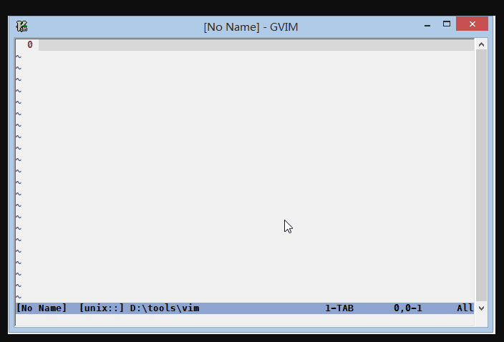

Then you exit by Ctrl+Z

The reason why is because It wants you to tell why the automatic merge should happen. When you have exited the Vim terminal. You can do a

git commit –am “Commit message goes here“

again. Just hit Arrow up to get the last commit command you used.

This should cover the basics, your Git-meister should know the rest